G90C Specification
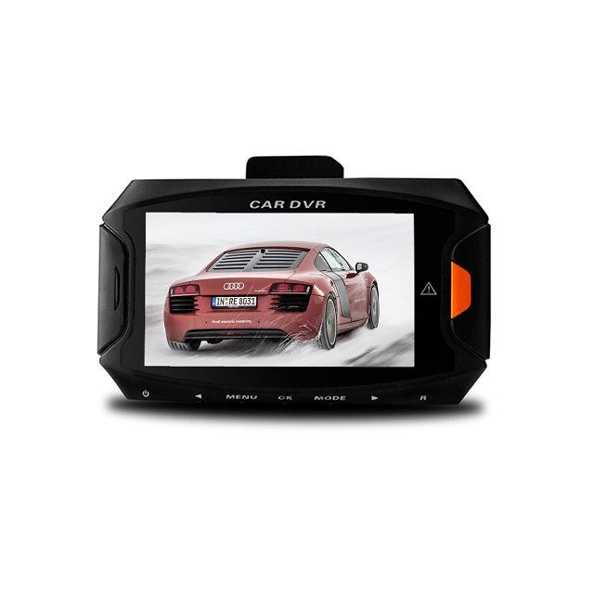
G90C is a state-of-the-art dash cam that supports the 2560×1080 as well as the 1296p formats. It also support Full HD1920x1080P@60fps. With Ambarella A7LA70 Chipset Plus OV4689 Sensor. 4.0 Mega Pixel. It records very good video quality both at day and at night, and supports ADAS Calibration like LDWS, FCWS, PDSW, HBM, TSR, etc. If you are looking for great video footage at the highest resolutions available and ADAS in 2015, go for this one.
This Cam is great aid for driving and proves their worth in many different situations. They could record your memorable precious moments of your life and those recorded videos could also prove great evidence for some undesirable happenings .This camera records in a continuous loop so you could never miss a thing but the G-Sensor helps this device to save those important files from being overwritten which has recorded some important information and this Car DVR always protecting you when driving anywhere at anytime.
This little device gives you big peace of mind and security of your Car.
Glossary :
ADAS : Advanced Driver Assitance System
LDWS: Lane Departure Warning System
FCWS: Forward Collision Warning System
PDSW: Pedestrian Detection System
HBM: High Beam Assist
TSR: Traffic Sign Recognition
Specifications
Chipset Ambarella A7LA70
Sensor 5.0 MP COMS
Screen Size 2.7 Inch TFT LCD Screen
Color BLACK
Lens Angle 170 degree wide angle lens
HDR Function YES
Aperture Range F1.8
Focel Distance f=2.8mm
Decode Format H.264
Video Resolution 2560*1080 30fps /2304*1296 30fps/1920*1080 60fps/1920*1080 30fps/HDR1920*1080 30fps/1280*720p 60fps/1280*720 30fps
Video Format MOV
Photo Resolution 13M(4800*2700) 9M(4000*2250) 4M(2688*1512
Photo Format JPG
G-Sensor YES
Screen Resolution 960*240
Loop-cycle recording Off/1min/3min/5min
IR night Vision YES
White balance Auto/Cloudy/Sunny/Incandescent/D4000/D5000/Sunny
Exposure +0/-0.3/-0.7/-1/-1.3/-1.7/-2/+2.0/+1.7/+1.3/+1.0/+0.7/+0.3
Frequency 50HZ/60HZ
TV mode PAL/NTSC
HDMI output YES
Language English /Russian/Dutch, German, Czech, polish/Simplified Chinese/Traditional Chinese
Time Stamp YES
Auto-Power On YES
Auto-Power OFF OFF/1min/3min/5min
Delay Shutdown OFF/15sec/30sec/1min
Microphone YES
AV interface AV-OUT Mini HDMI
Data interface Micro USB
Working voltage DC 12~24V
Power Interface 5V 1.5A
Storage Expansion TF Card up to 32G
Battery lithium battery 150mAH
Product weight 71g
Package weight 360g
Product size(L*W*H) 8.6*5.2*3.8cm
Package size(L*W*H) 17.5*13.5*8.5cm

